**WATER LEVEL MONITORING SYSTEM**

**AIM: A low cost reconfigurable smart water level and usage monitoring system in IOT.**

**Introduction:**

One of the major problems faced by most of the countries is the issue of water scarcity in the world. In our day to day life water is being wasted in huge amounts. The water wastage is mainly due to improper management. So, we need to consume water in a efficient way which is a mainly source of need for the human lives. Therefore, the IOT based Water Level Monitoring is an innovative system which will provide the information to people about the level of liquid and will prevent it from overflowing. In this project we are using ultrasonic sensor which is used to send the distance of water in the tank to Aurdino. An Aurdino is the development board and water level will be displayed in the lcd to know the level present in the tank. Therefore ,the ultimate aim of this project is to reduce water scarcity by controlling the motor automatically to be switched on and off according to the water level.

**Hardware Requirements:**

* Aurdino uno
* LCD
* Ultrasonic sensor
* Bread board
* Jumper wires
* USB type A to type B cable
* Submersible pump
* Relay
* Buzzer

**Circuit Diagram:**

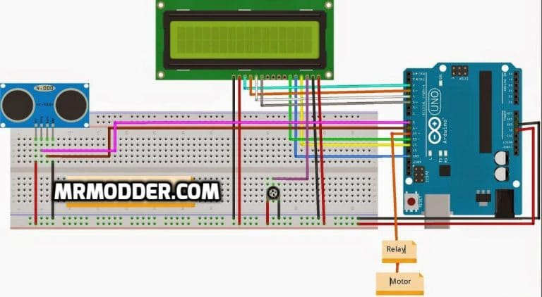

**Program:**

#include<LiquidCrystal.h> // include the library code for lcd

LiquidCrystal lcd(12, 11, 5, 4, 3, 2);

#define echopin 9 // echo pin

#define trigpin 8 // Trigger pin

int maximumRange = 50;

long duration, distance;

String data;

int Buzzer = 7;

int relay = 10;

void setup()

{

lcd.begin(16,2);

Serial.begin (9600);

pinMode (trigpin, OUTPUT);

pinMode (echopin, INPUT );

pinMode (4, OUTPUT);

pinMode (relay,OUTPUT);

pinMode(Buzzer,OUTPUT);

}

void loop ()

{

digitalWrite(trigpin,LOW);

delayMicroseconds(2);

digitalWrite(trigpin,HIGH);

delayMicroseconds(10);

duration=pulseIn (echopin,HIGH);

distance= duration/58.2;

Serial.println(distance);

delay (50);

Serial.println(distance);

lcd.clear();

lcd.setCursor(0,0);

lcd.print("water level :");

lcd.print(distance);

delay(100);

if (distance >= 25 ){

digitalWrite (7,HIGH);// connect to relay(motor)

digitalWrite (relay,LOW);

lcd.setCursor(0,1);

lcd.setCursor(7, 1);

lcd.print("Motor Started");

Serial.print("motor started");

delay(100);

}

else if (distance <=5) {

digitalWrite (7,LOW); // connect to relay(motor)

digitalWrite (relay,HIGH);

lcd.setCursor(0,1);

lcd.print("Tank is full");

Serial.print("motor stoped");

delay(100);

}

}

**Procedure:**

* Arduino reads the time between triggering and received ECHO.
* We know that speed of sound is around 340 m/s. so we can calculate distance by using given formula:

Distance= (travel time/2) * speed of sound.

* We get the distance of water level from the top by using the ultrasonic sensor.
* The distance of the water level that we get from the sensor will be sent to the aurdino.
* The aurdino board helps us to display the level on the LCD.
* This level is made to operate the motor by using the relay as switch.
* Thus, motor will automatically be switched on and off according to the water level.

**Output:**

**Result:** If water is filling above the tank the the ultrasonic sensor sense and stops the stepper motor then buzzer will start after the stepper motor stops.